

**Capstone Project**

Rheinol Quick Service

|  |  |
| --- | --- |
| **Group 15 – IS** | |
| **Group members** | Lê Đình Thiện Vũ – SE62590 (Leader)  Phan Ánh Phúc – SE62543  Đặng Hữu Phương Nam – SE62167 |
| **Supervisor** | Nguyễn Thị Cẩm Hương |
| **Ext. Supervisor** | N/A |
| **Project Code** | Rheinol Quick Service |

– **Ho Chi Minh, 18th Aug 2019** –

**REPORT TESTING**

**Table of Contents**

A. Customer Test Case 5

1. Search product, service 5

1.1 Search product, service don’t have in the database 5

1.2 Search product, service have in the database 7

2. Book service 9

2.1 Book service on busy slot 9

2.2 Book service on free slot 13

3. Add cash to Rheinol wallet 14

3.1 Add cash is smaller than the minimum required cash 14

3.2 Add cash is larger than the minimum required cash 15

4. Payment by Rheinol wallet 17

4.1 Payment with the bill have the total money are larger than the balance of the wallet 17

4.2 Payment with the bill have the total money are smaller than the balance of the wallet 18

5. Sign in 19

5.1 Sign in with invalid username or password or both. 19

5.2 Sign in with valid username and password 22

6. Sign up 24

6.1 Sign up with email or username is existed. 24

6.2 Sign up with email or username has not existed. 25

B. Sales Clerk Test Case 27

1. Manage account 27

1.1 Create an account with missing required fields 27

1.2 Create an account with all required fields 27

1.3 Lock account 27

2. Manage order 27

2.1 Create order with missing product and service 27

2.2 Create order with one of product or service 27

2.3 Edit order with remove all product and service 27

C. Admin Test Case 27

1. Manage product 27

1.1 Create a product with missing required fields 27

1.2 Create a product with all the required fields. 27

2. Manage promotion 27

2.1 Create a promotion with missing required fields 27

2.2 Create a promotion with all the required fields. 27

3. Manage category 27

3.1 Create a category with missing required fields 27

3.2 Create a category with all the required fields. 27

**List of figures**

Figure 1 - Search product, service not found 6

Figure 2 - Search product, service not found 7

Figure 3 - Search product, service not found 8

Figure 4 - Search product, services 9

Figure 5 - Search product, service 10

Figure 6 - Book service on busy slot 11

Figure 7 - Book service on busy slot 12

Figure 8 - Book service on busy slot 13

Figure 9 - Book service on free slot 14

Figure 10 - Add money is the smaller minimum required 15

Figure 11 - Add money is larger or equal than the minimum required 16

Figure 12 - Add money is larger or equal than the minimum required 17

Figure 13 - Payment when not enough balance 18

Figure 14 - Payment when enough balance 19

Figure 15 - Payment when enough balance 20

Figure 16 - Sign in fail 21

Figure 17 - Sign in fail 22

Figure 18 - Sign in success 23

Figure 19 - Sign in success 24

Figure 20 - Sign up with invalid username or email 25

Figure 21 - Sign up with a valid username and email 26

Figure 22 - Sign up with a valid username and email 27

Figure 23 - Create an account with missing required fields 28

Figure 24 - Create an account with all required fields 28

Figure 25 - Lock account 29

Figure 26 - Lock account 29

Figure 27 - Create order with missing product and service 30

Figure 28 - Create order with product or service 30

Figure 29 - Edit order to remove all product and service 31

Figure 30 - Create a product with missing required fields 31

Figure 31 - Create a product with all required fields 32

Figure 32 - Create promotion with missing fields 32

Figure 33 - Create promotion with all required fields 33

Figure 34 - Create a category with missing fields 33

Figure 35 - Create a category with all required fields 34

1. Customer Test Case
   1. Search product, service
      1. Search product, service don’t have in the database

* Go to all product screen or all service screen
* Input name of product or service that doesn’t have in the database
* Choose search with product or service

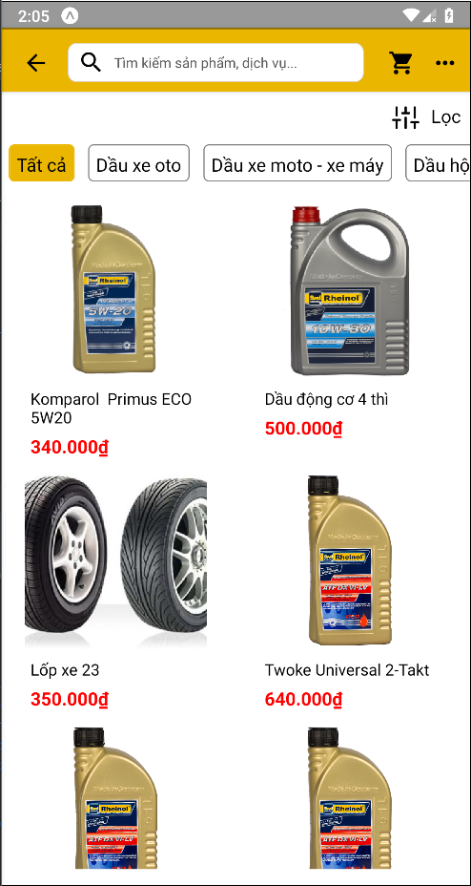

Figure - Search product, service not found

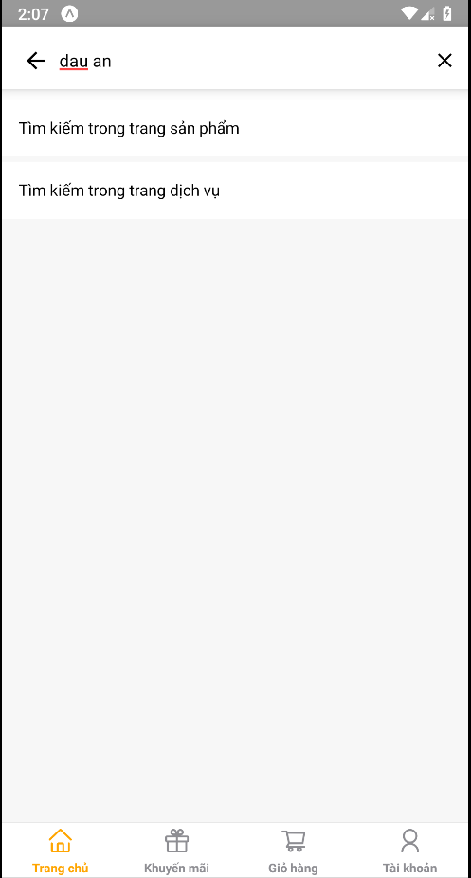

Figure - Search product, service not found

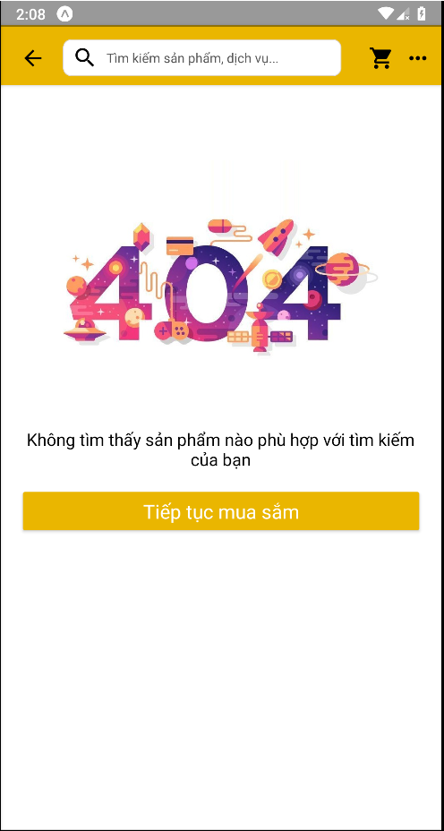

Figure - Search product, service not found

* + 1. Search product, service have in the database
* Go to all product screen or all service screen
* Input name of product or service that have in the database
* Choose search with product or service

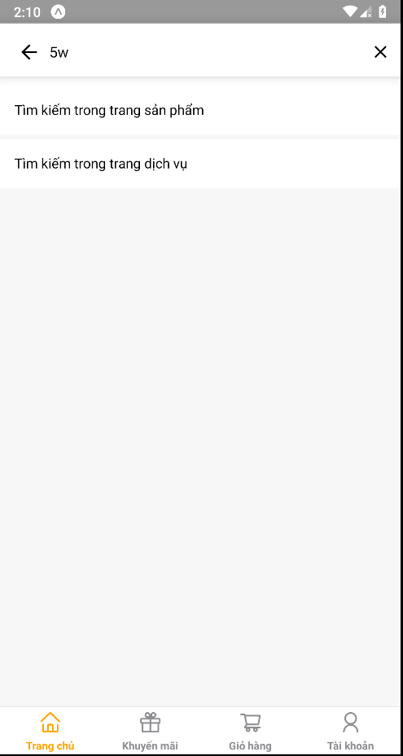

Figure - Search product, services

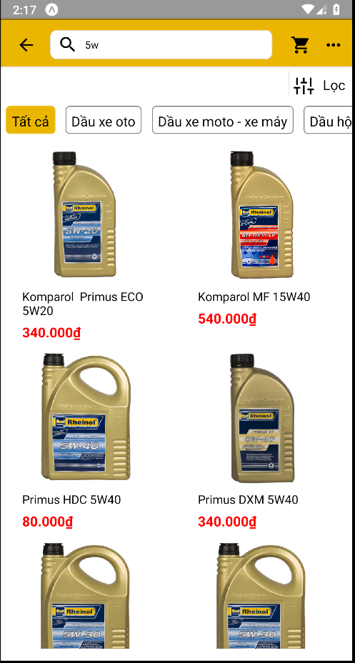

Figure - Search product, service

* 1. Book service
     1. Book service on busy slot
* Choose service to book
* Choose a date to do that service
* The system provides information about busy slot
* Choose an hour is belong to busy hours slot

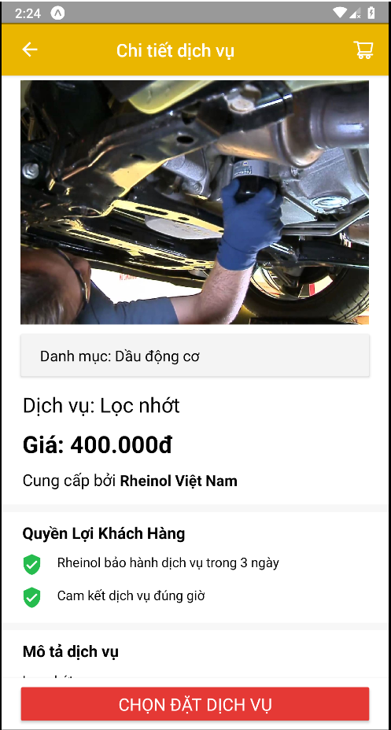

Figure - Book service on busy slot

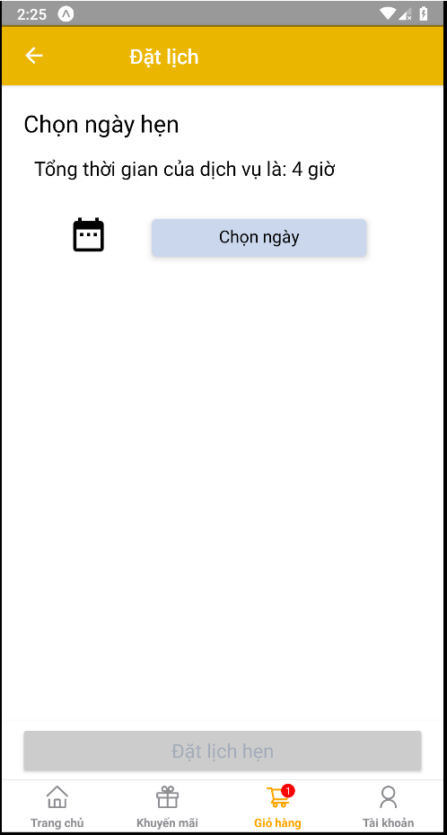

Figure - Book service on busy slot

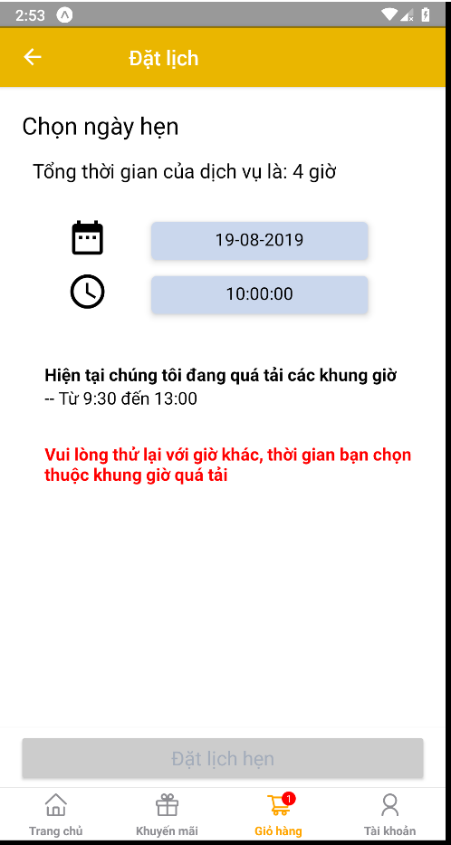

Figure - Book service on busy slot

* + 1. Book service on free slot
* Choose service to book
* Choose a date to do that service
* The system provides information about busy slot
* Choose an hour is outside busy hours slot

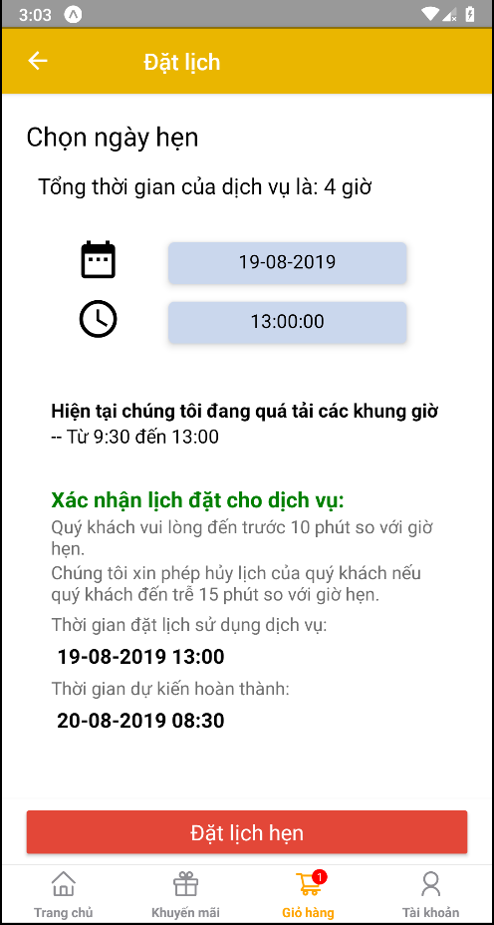

Figure - Book service on free slot

* 1. Add cash to Rheinol wallet
     1. Add cash is smaller than the minimum required cash
* Add 15.000đ to Rheinol wallet (minimum is 20.000đ)

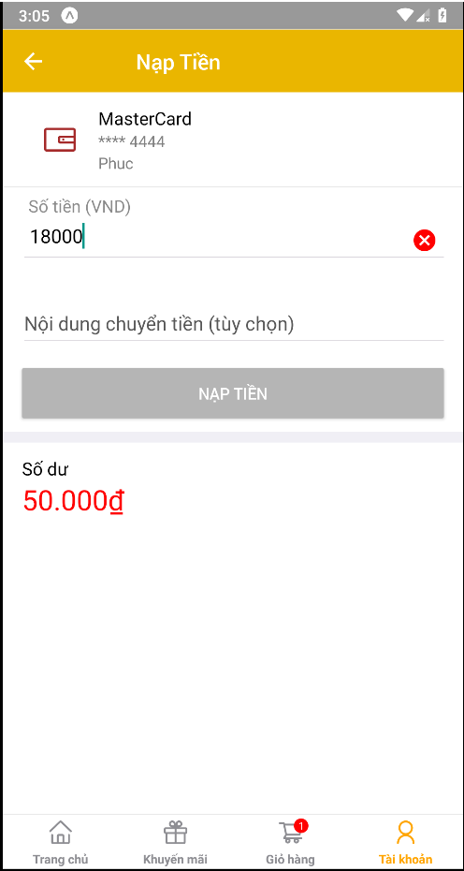

Figure - Add money is the smaller minimum required

* + 1. Add cash is larger or equal than the minimum required cash
* Add 20.000đ to Rheinol wallet (minimum is 20.000đ)

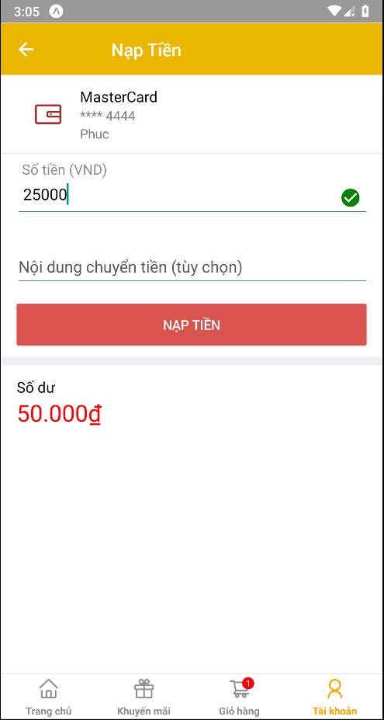

Figure - Add money is larger or equal than the minimum required

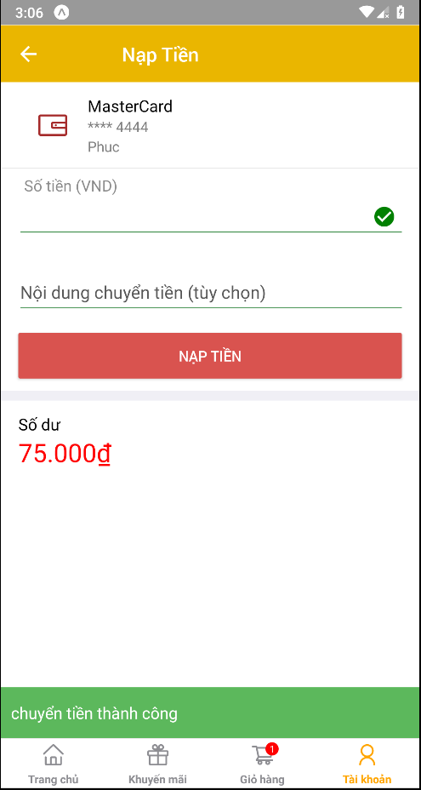

Figure - Add money is larger or equal than the minimum required

* 1. Payment by Rheinol wallet
     1. Payment with the bill have the total money are larger than the balance of the wallet
* Go to all product screen
* Add product to cart
* Do payment with the balance in the wallet is smaller than total money in bills

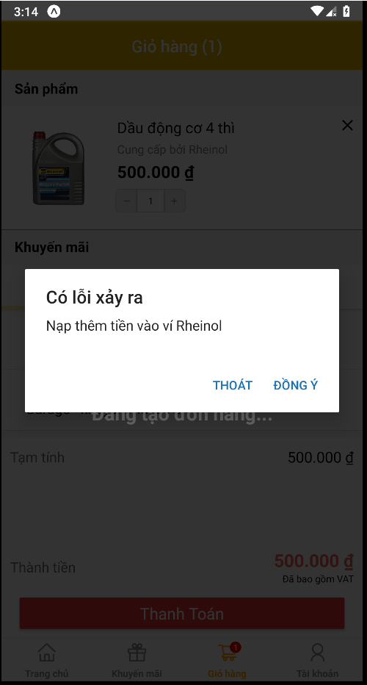

Figure - Payment when not enough balance

* + 1. Payment with the bill have the total money are smaller than the balance of the wallet
* Go to all product screen
* Add product to cart
* Do payment with the balance in the wallet is larger than total money in bills

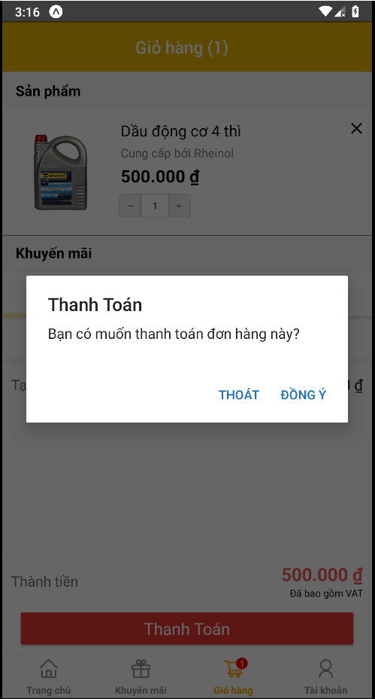

Figure - Payment when enough balance

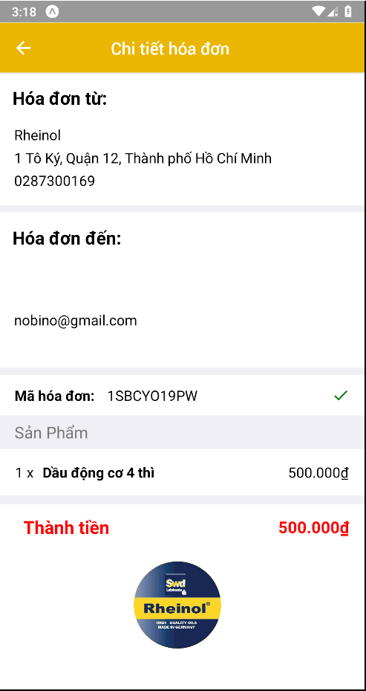

Figure - Payment when enough balance

* 1. Sign in
     1. Sign in with invalid username or password or both.
* Input invalid username and password
* Press the sign-in button

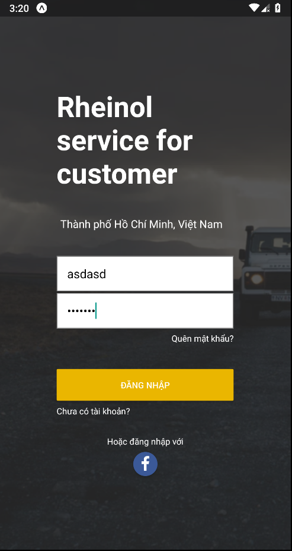

Figure - Sign in fail

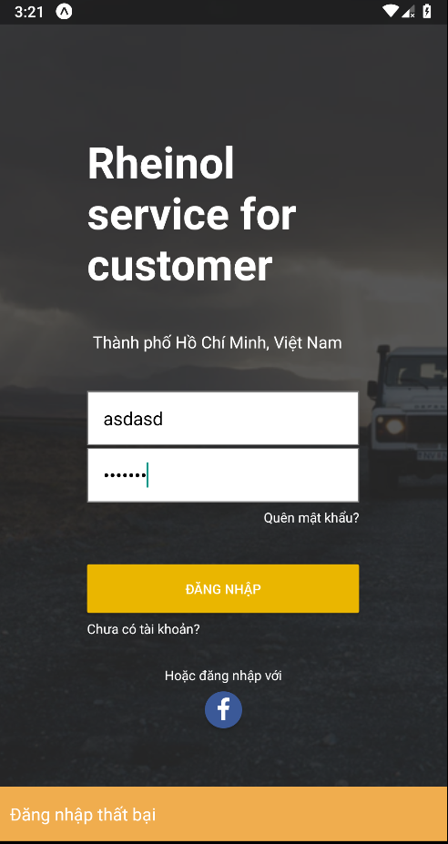

Figure - Sign in fail

* + 1. Sign in with valid username and password
* Input valid username and password
* Press the sign-in button

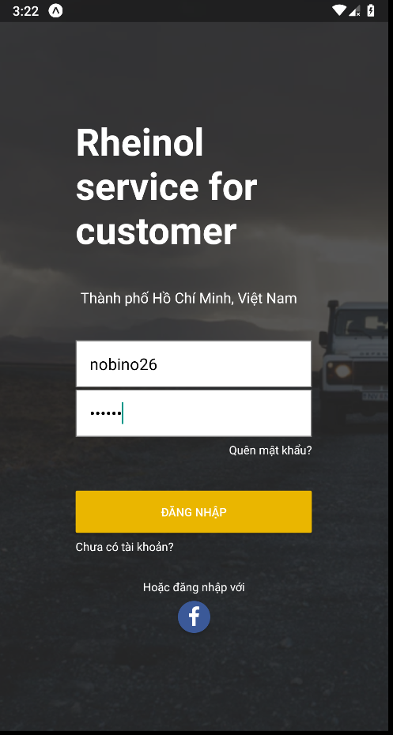

Figure - Sign in success

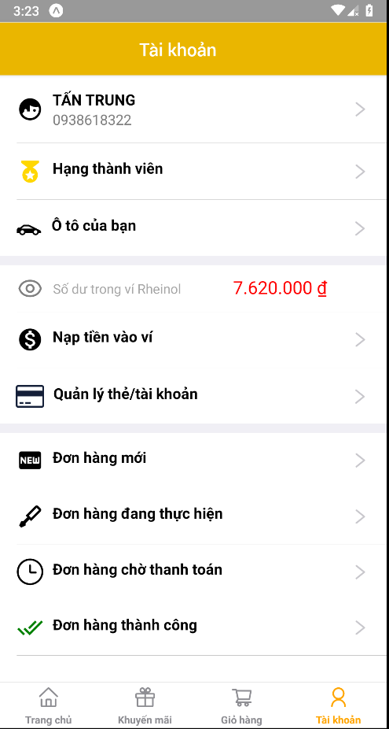

Figure - Sign in success

* 1. Sign up
     1. Sign up with email or username is existed.
* Input an email or username that is registered in Rheinol

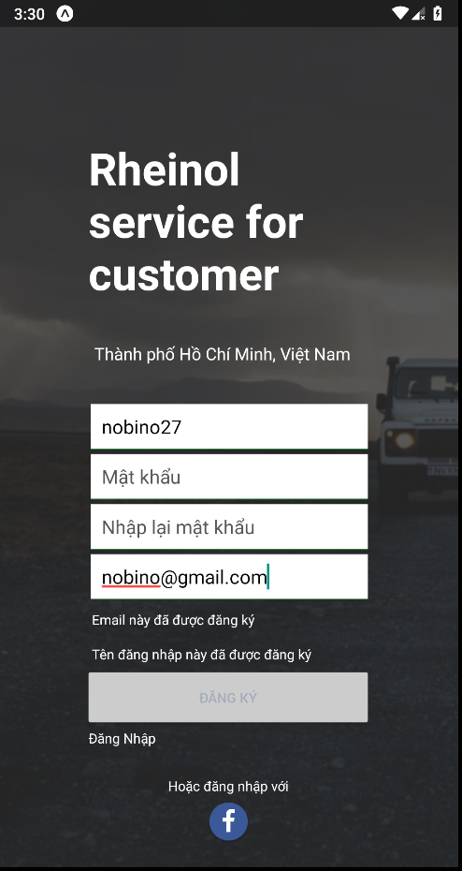

Figure - Sign up with invalid username or email

* + 1. Sign up with email or username has not existed.
* Input an email or username that does not exist in Rheinol
* Press the register button

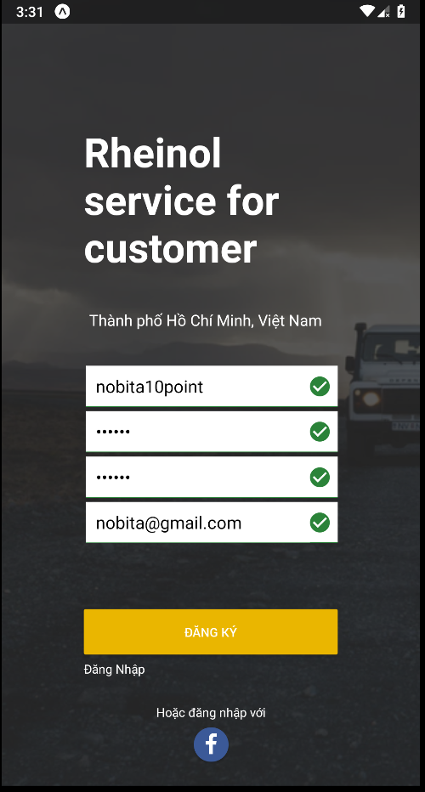

Figure - Sign up with a valid username and email

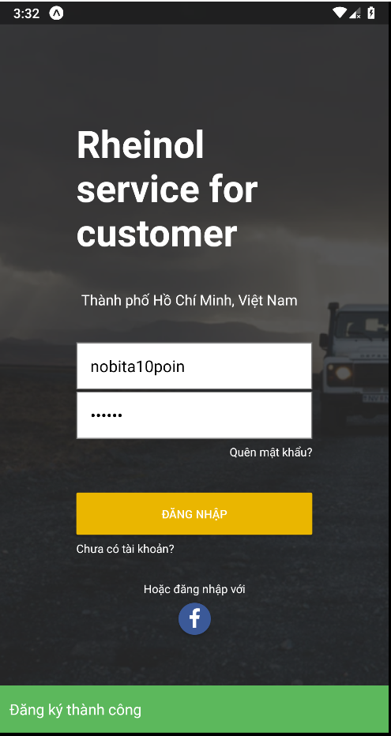

Figure - Sign up with a valid username and email

1. Sales Clerk Test Case
   1. Manage account
      1. Create an account with missing required fields

* If I have a required field is missing that “Thêm mới” button is disabled

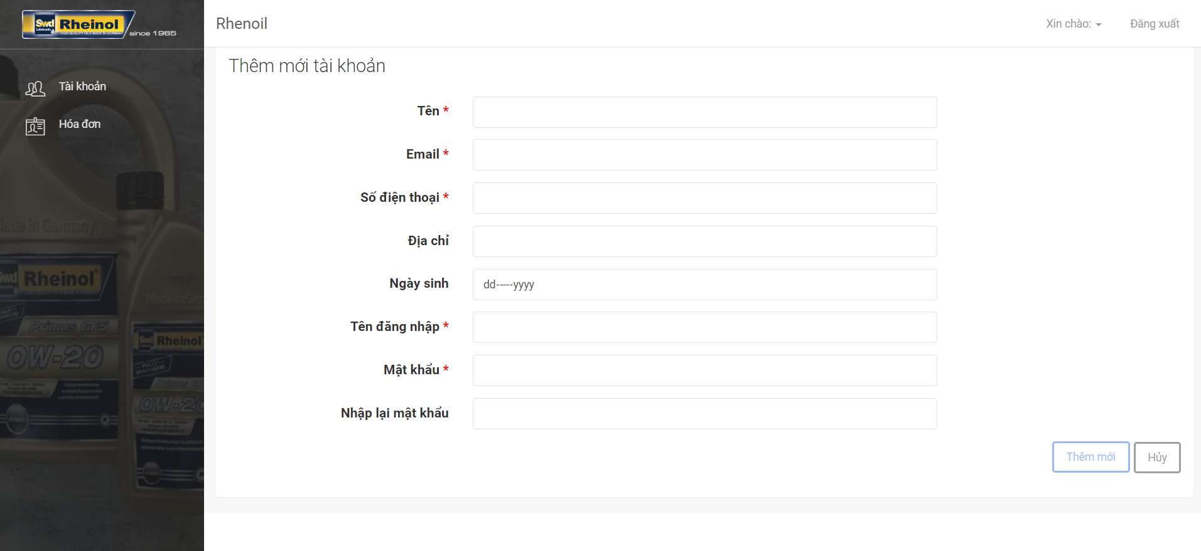

Figure - Create an account with missing required fields

* + 1. Create an account with all required fields
* If don’t have required fields is missing that “Thêm mới” button is enabled

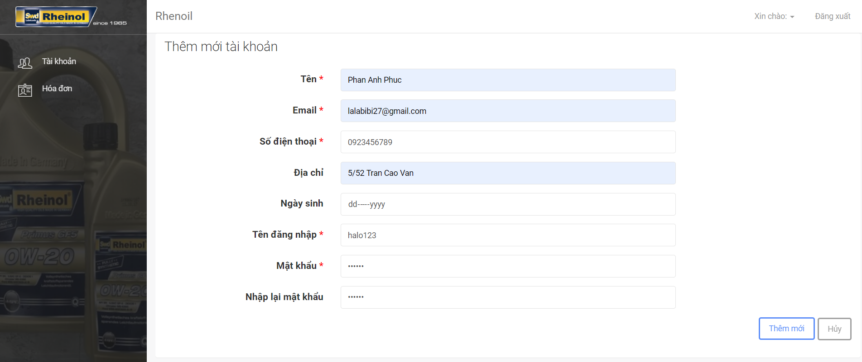

Figure - Create an account with all required fields

* + 1. Lock account
* Choose the account you want to lock
* Confirm “Đổi” to lock this account
* Lock account is account have a lock icon with grey color

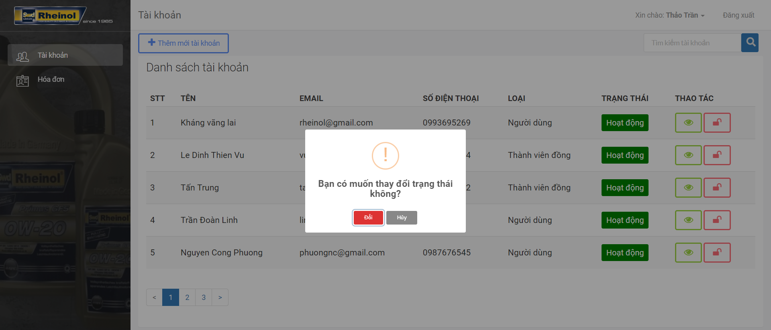

Figure - Lock account

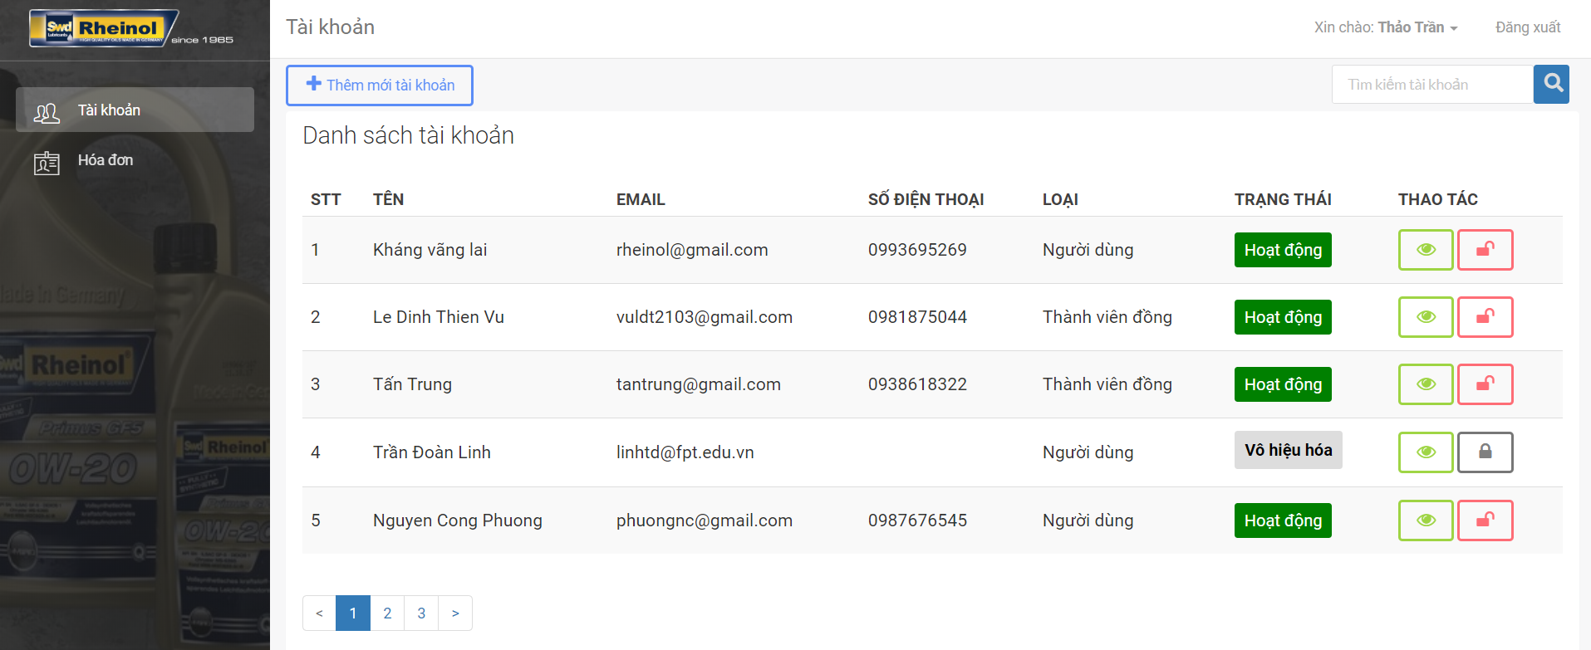

Figure - Lock account

* 1. Manage order
     1. Create order with missing product and service
* Input name of customer
* “Thêm mới” button is disabled because there is no product or service in order

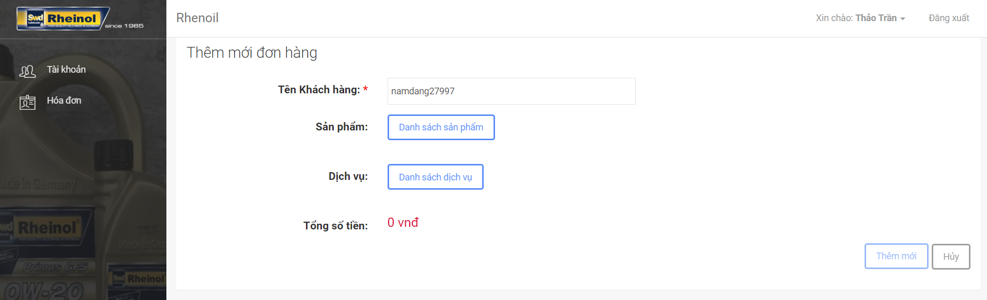

Figure - Create order with missing product and service

* + 1. Create order with one of product or service
* Input name of customer
* Add a product or service into order
* “Thêm mới” button is enabled

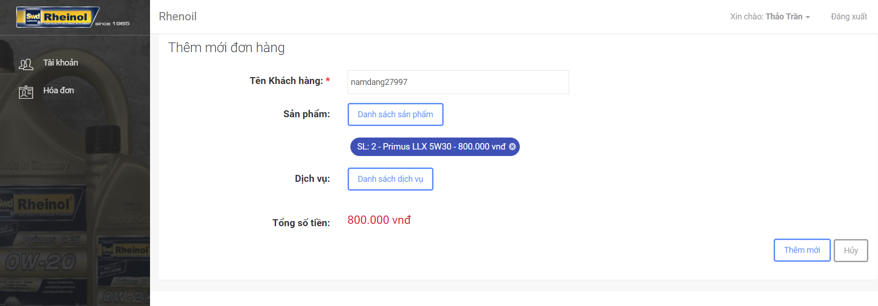

Figure - Create order with product or service

* + 1. Edit order with remove all product and service
* Remove all product and service in order
* “Thêm mới” button is disabled

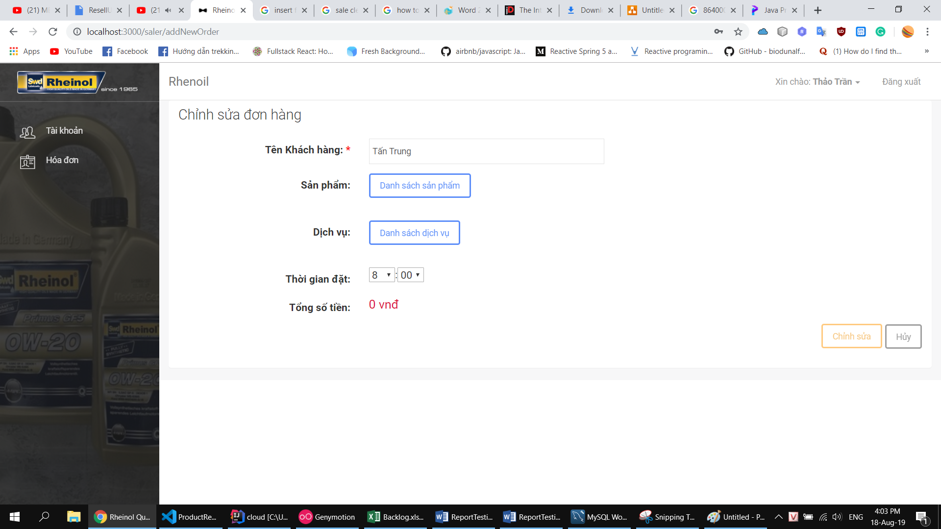

Figure - Edit order to remove all product and service

1. Admin Test Case
   1. Manage product
      1. Create a product with missing required fields

* Have a field in required fields is missing
* “Thêm mới” button is disabled

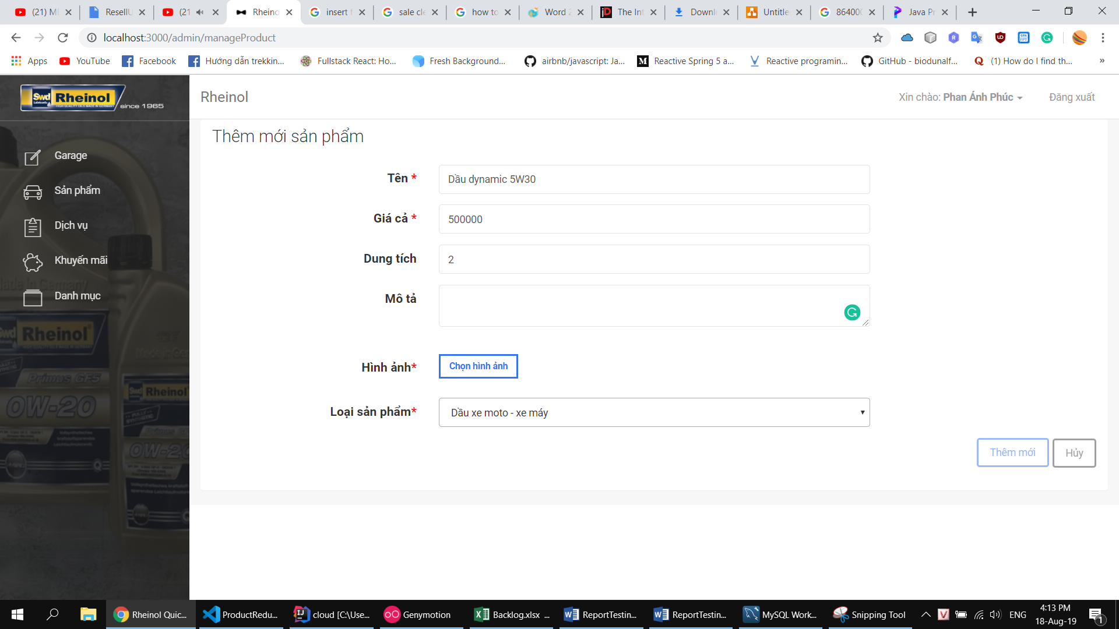

Figure - Create a product with missing required fields

* + 1. Create a product with all the required fields.
* All field is inputted
* “Thêm mới” button is enabled

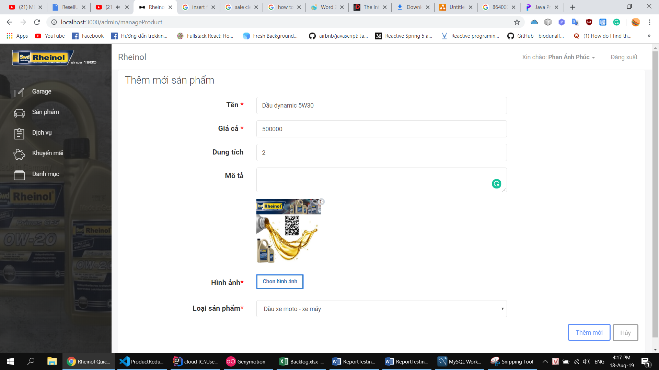

Figure - Create a product with all required fields

* 1. Manage promotion
     1. Create a promotion with missing required fields
* Have a field in required fields is missing
* “Thêm mới” button is disabled

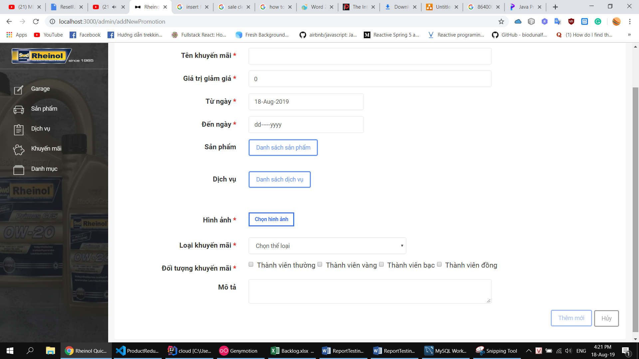

Figure - Create promotion with missing fields

* + 1. Create a promotion with all the required fields.
* All field is inputted
* “Thêm mới” button is enabled

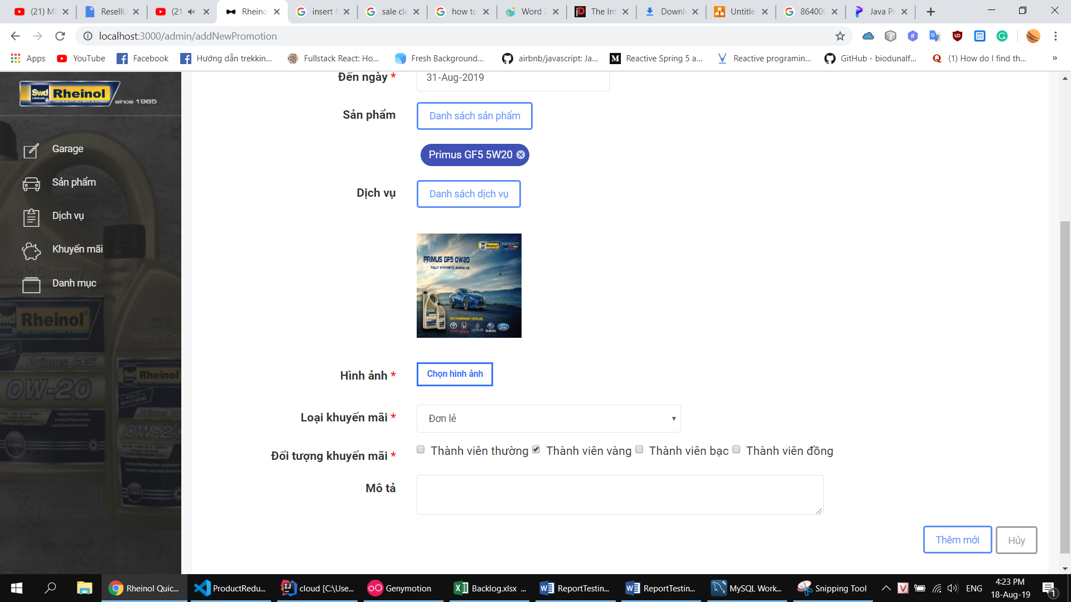

Figure - Create promotion with all required fields

* 1. Manage category
     1. Create a category with missing required fields
* Have a field in required fields is missing
* “Thêm mới” button is disabled

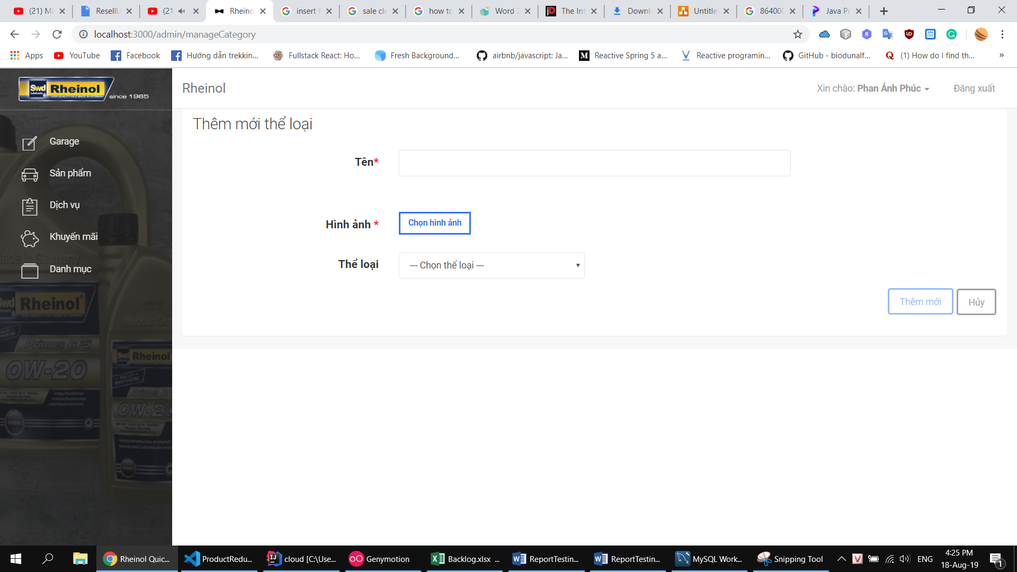

Figure - Create a category with missing fields

* + 1. Create a category with all the required fields.
* All field is inputted
* “Thêm mới” button is enabled

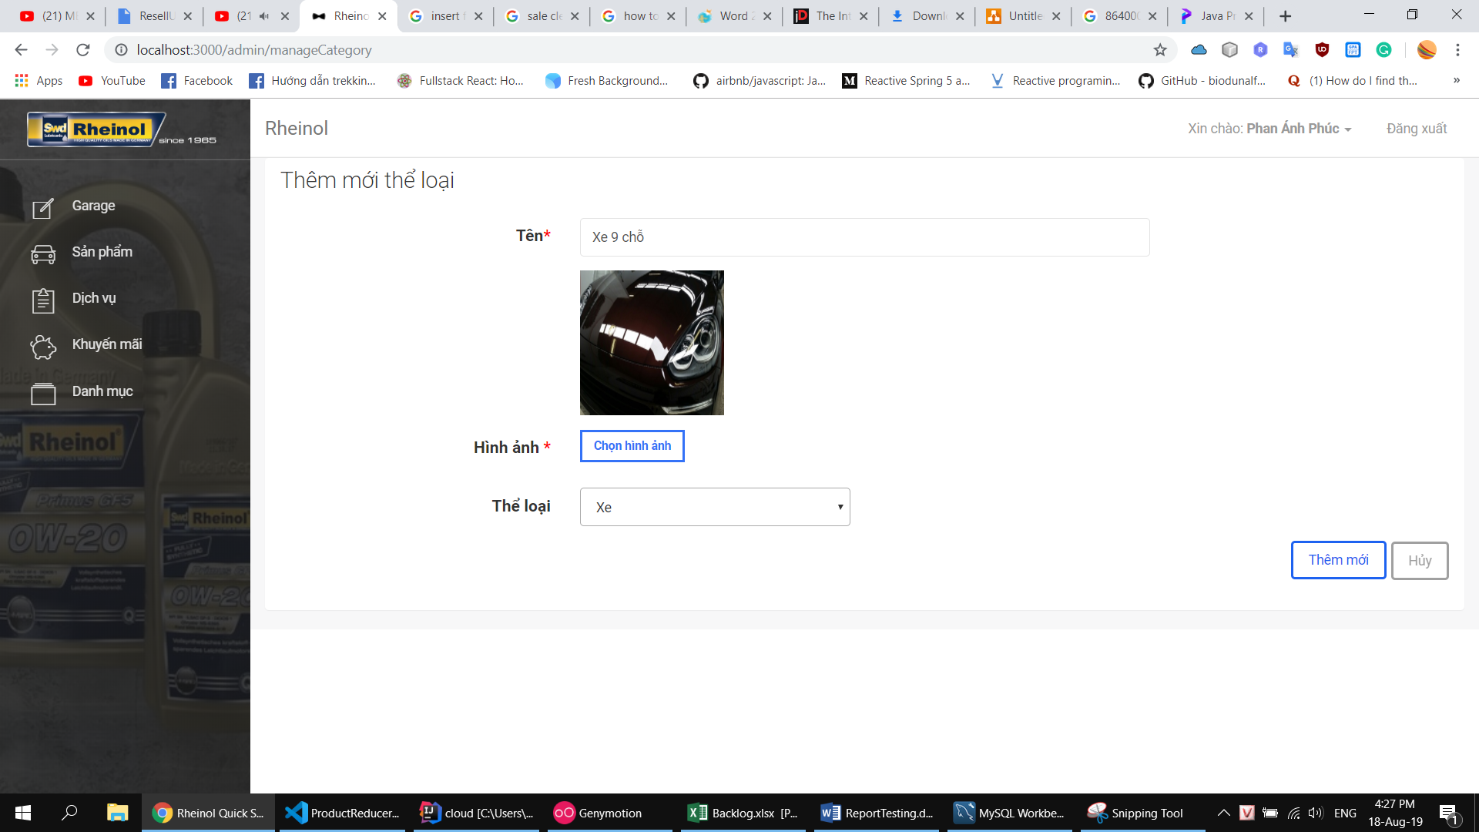

Figure - Create a category with all required fields